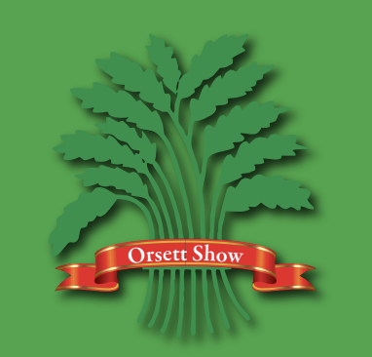

Horse Section Sponsorship Options 2024

£50 – one class set of Rosettes with choice of information on tails, option to present your own rosettes on the day and mention on social media and show day by commentator.

£75 – two class set of Rosettes with choice of information on tails, option to present your own rosettes on the day and mention on social media and show day by commentator.

£100 – Orsett Show Championship classes – choice of Show jumping, dressage or Showing, two sashes & one set of rosettes with choice of information on sash/tails.

£200 – Display your banner (that you provide) in one of the horse show rings, recognition of your business in a show programme, your company details link on our website and social media, two general admission passes.

Or

£200 – 5 class set of Rosettes with choice of information on tails, option to present your own rosettes on the day, recognition of your business in a show programme, your company details link on our website and social media, two general admission passes.

£300 – ¼ a5 advert in a show programme, display your banner (that you provide) in one of the horse show rings, recognition of your business in a show programme, your company details link on our website and social media, two general admission passes, two lunches in the equestrian catering marquee.

£500 - ½ a5 advert in a show programme, display your banner (that you provide) in one of the horse show rings, recognition of your business in a show programme, your company details link on our website and social media, 50% discount (size dependant) on trade stand two general admission passes, two lunches in the equestrian catering marquee and Members Parking for 1 car.

£1000 – Free trade stand (size dependant), ½ a5 advert in a show programme, display your banner (that you provide) in one of the horse show rings, recognition of your business in a show programme, your company details link on our website and social media, four general admission passes, four lunches in the equestrian catering marquee and members parking for 1 car.

Bespoke packages can be arranged, please contact us at horsesection@orsettshow.co.uk to discuss.

